ELEC 2210 LABORATORY REPORT COVER PAGE

Complete and attach this page to the front of your lab report.

Meeting # 002 EXPERIMENT 3: Medium Scale Integrated (MSI) Circuits *Title of Lab Experiment*

Student Name: Howard Jacob, A

*Name (Last, First, MI)*

Student Email: JAH0147

*AU 7-character username*

GTA: Jonathan

*Name of your GTA*

The section you are enrolled in: (Circle One): 1 2 3 4 5 6 7 8

Date experiment performed (dd / mm / yy): 22/9/20

Date report submitted: (dd / mm / yy): 29/9/20

If you performed this experiment at a time other than your regularly scheduled section meeting:

Section # of the section you sat in on (Circle One): 1 2 3 4 5 6 7 8 Makeup

Name of the GTA who supervised your work: None

I hereby certify that the contents of this report are true and complete to the best of my ability. The lab work was performed by me exclusively, and this report was written by me exclusively.

Jacob Howard 22/9/20

Student signature Date signed

ELEC-2210

Digital Electronics

FROM: Jacob Howard

TO: Jonathan

DATE: 9/29/20

LAB SECTION: 002 (Tuesday, 1:00pm-2:50 pm)

EXPERIMENT 6:

Diodes and rectifiers

# **Introduction**

# In this lab report we reviewed the functioning of both DC and AC diodes. We used the diodes to understand and build diode rectifier circuits. This is really helpful because we were able to see how everything that we have learned in the lectures works in a real circuit.We used the ELVIS board to assemble our circuits like always.

# **Step 1**

This lab experiment has 3 parts and a bonus. For the First Part we connected a circuit shown in Image 1 in the ELVIS board and proceeded to test it with varying voltage sources. At first we used +15V as the source. When this source was active the green and yellow LEDs were turned on. We then switched the source to -15V. With this new source active, the red and yellow LEDs turned on. The reason why the green and red LEDs don’t light up at the same time is because of the way the LEDs were placed. When the positive voltage is inputted then the current will flow through the positive end of the first green diode, continue to both yellow diodes and end in the second green LED. When we used a negative voltage, the current would flow through through the negative end of the LEDs, lighting up the first red LED, then the two yellow ones and the second red as last. Step one was a pretty simple process.

**Step 2**

For part 2, we connected the circuit that was given to us. Making sure that BananaA and BananaB were connected to the Digital Multi Meter connectors, we then downloaded the provided program and plotted the IV characteristics of the provided diode. The obtained plot is shown in *Figure* 1. The data for the graph is shown in *Table 1*. We then followed another provided image of a circuit. Following similar steps as in the previous step we downloaded the necessary program. With some different values for the start voltage, stop voltage and number of steps we found a different plot. This graph is shown in *Figure 2.* The data collected for figure 2 is shown in *Table 2.*

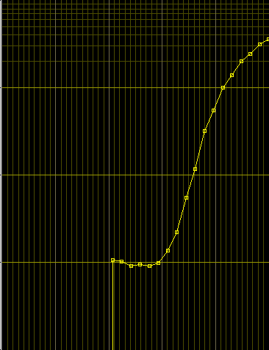

*Figure 1*

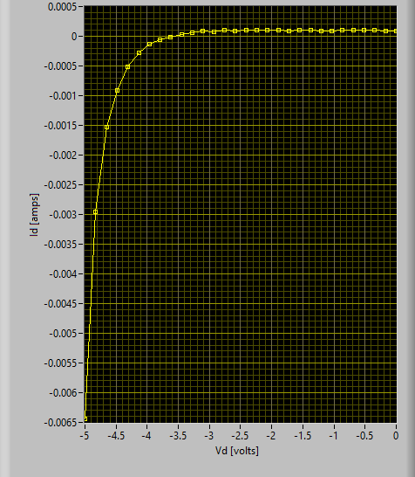

*Figure 2*



*Table 1*



*Table 2*

# **Step 3**

# In step 3, we were asked to construct the circuit in *Figure 3* on the breadboard. We then set the function generator to 10 volts peak-to-peak to produce a 5 volt peak. We used the oscilloscope to measure the capasitor voltage and show the ripple voltage. The graph we were to produce in the oscilloscope is shown in *Figure 4.*

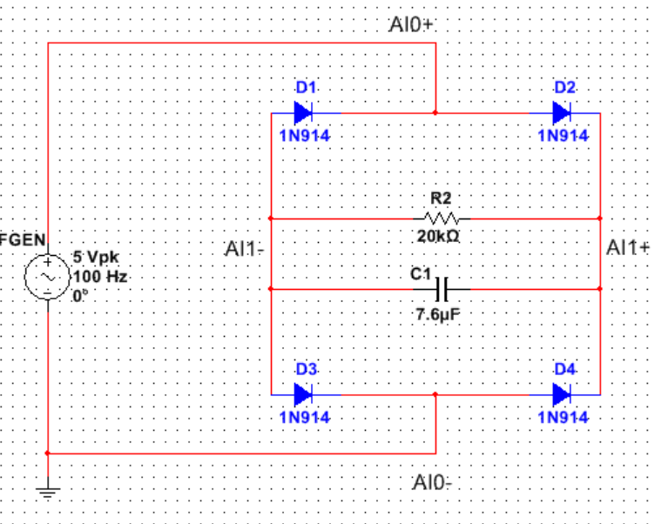

*Figure 3*

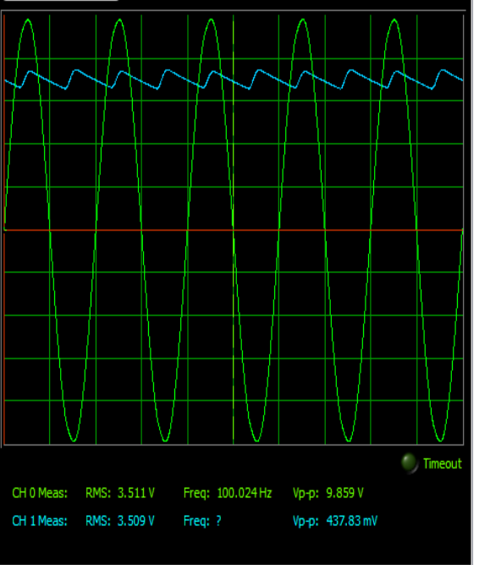

*Figure 4*

# **Step 4**

# Step 4 was for bonus and I did not get to this part. I had just finished step 3 before it was time to clean up the lab station and leave.

# **Conclusion**

This was our first lab with diod circuits. The lab was very interesting and helped us understand some of the basic information we have been learning in the leactures. Overall, this lab was not too difficult and was a good first lab that introduced us to the real world circuits we have been learning in class